

**Mitsubishi FDTC45KXE6F VRF Compact**

**Rs. 80,400/-**

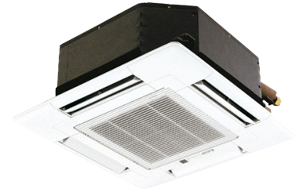

**Product Features**

* Antifouling and Movable Baffle
* Compact Design
* 3D airflow
* Rounding Natural Air
* Built In High Head Drain Pump

**Specification**

**Type** Ceiling Cassette AC

**Cooling (Btu/h)** 55000

**Voltage (V)** 220-240

**Power Input (W)** 3800

**EER (Btu/W-h-W/W)** 6.9-4.1